trabalho de arq
Politica de realocamento, FIFO. First in, First Out. obteve taxa de Miss Rate: 94%
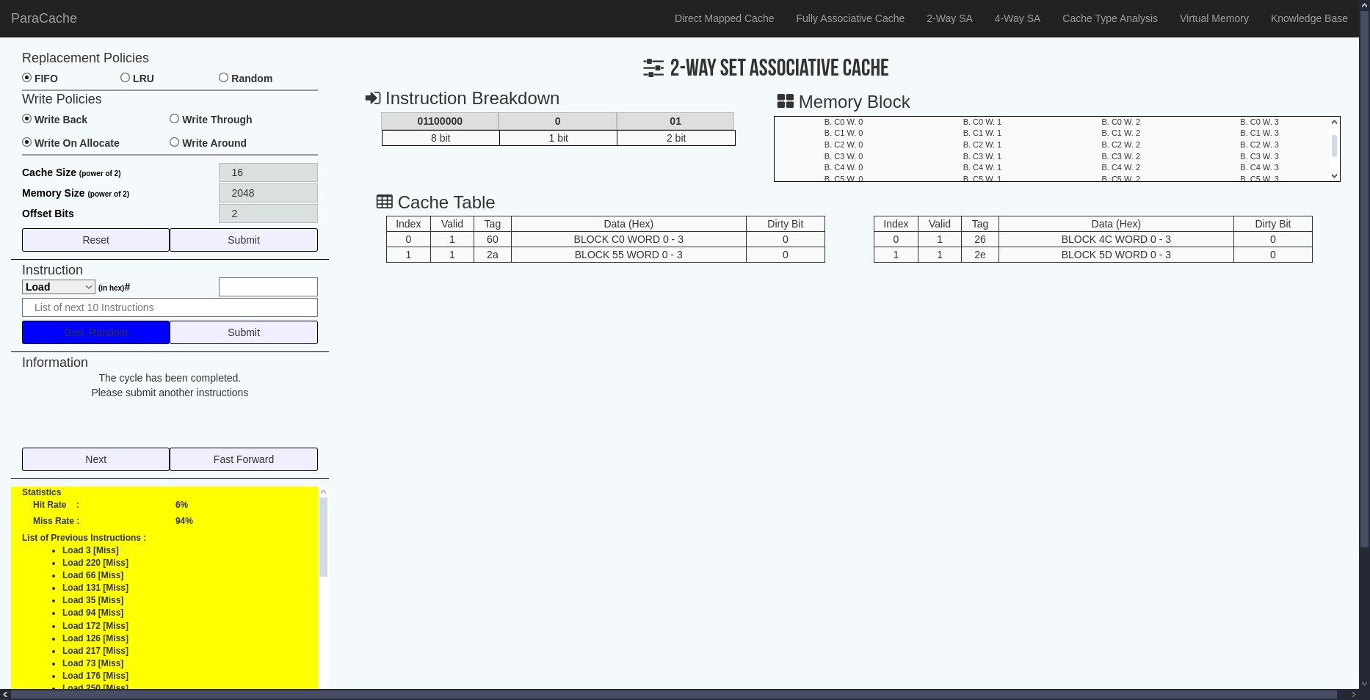
taxa de Hit Rate: 6%
Politica de realocamento, LRU, Least Recently Used. obteve taxa de Miss Rate: 94%
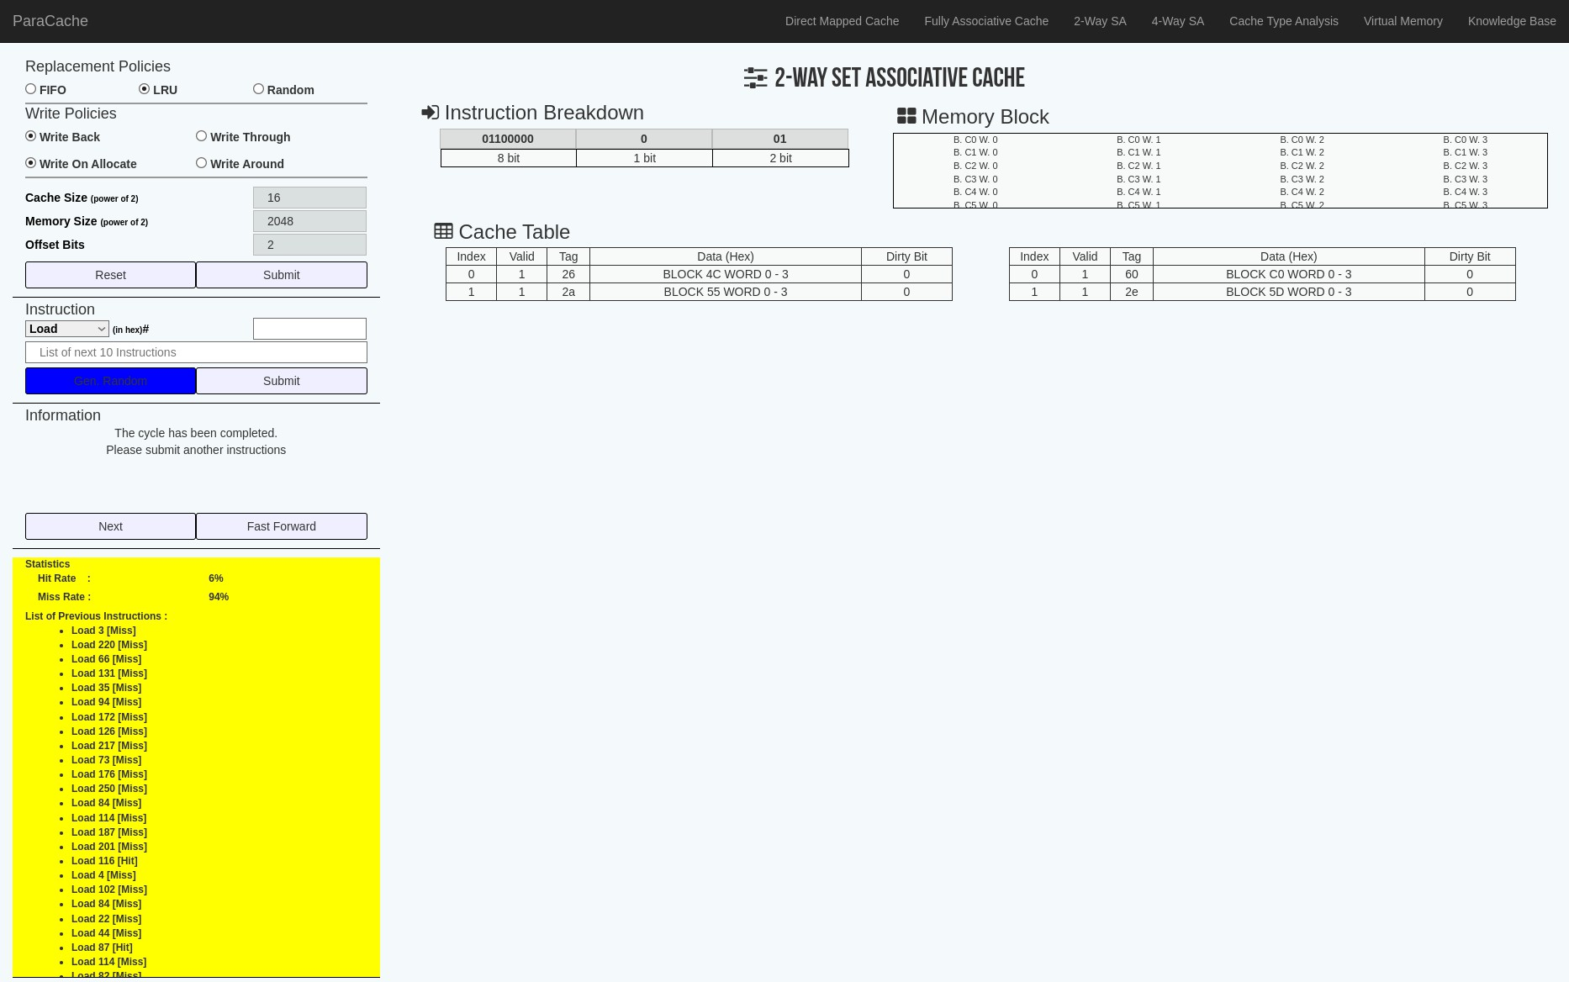
taxa de Hit Rate: 6%

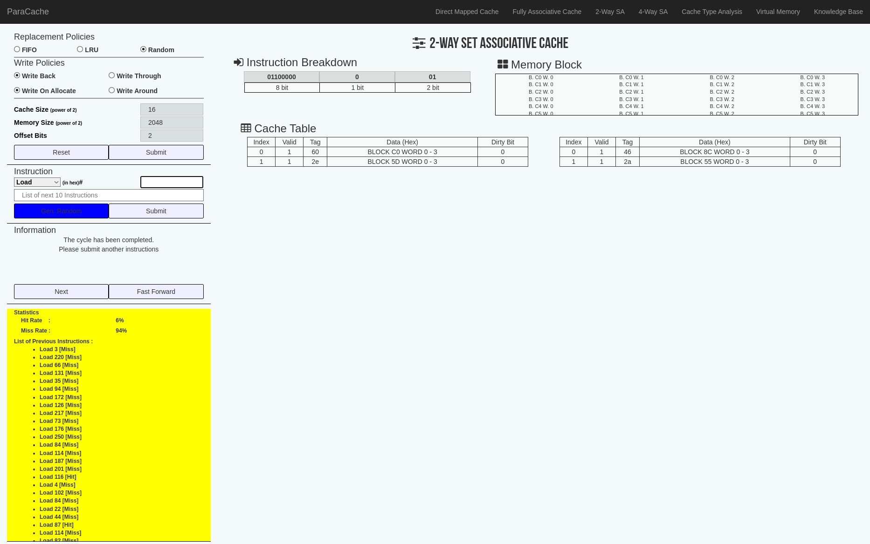
politica de realocamento, Random. obteve taxa de Miss Rate: 94% taxa de Hit Rate: 6%

